Software Requirements Specification

for

TV Trivia Maze

Version 1.0 approved

Prepared by Laura Humphreys

The Illuminati

May 14, 2015

Table of Contents

Table of Contents ii

Revision History ii

1. Introduction 1

1.1 Purpose 1

1.2 Document Conventions 1

1.3 Intended Audience and Reading Suggestions 1

1.4 Project Scope 1

1.5 References 1

2. Overall Description 2

2.1 Product Perspective 2

2.2 Product Features 2

2.3 User Classes and Characteristics 2

2.4 Operating Environment 2

2.5 Design and Implementation Constraints 2

2.6 User Documentation 2

2.7 Assumptions and Dependencies 3

3. System Features 3

3.1 System Feature 1 3

3.2 System Feature 2 (and so on) 4

4. External Interface Requirements 4

4.1 User Interfaces 4

4.2 Hardware Interfaces 4

4.3 Software Interfaces 4

4.4 Communications Interfaces 4

5. Other Nonfunctional Requirements 5

5.1 Performance Requirements 5

5.2 Safety Requirements 5

5.3 Security Requirements 5

5.4 Software Quality Attributes 5

6. Other Requirements 5

Appendix A: Glossary 5

Appendix B: Analysis Models 5

Appendix C: Issues List 5

**Appendix D: Diagrams 5**

Class Diagram 6

Sequence Diagram 7

Conceptual Model 8

Use Case Diagram 9

Revision History

|  |  |  |  |
| --- | --- | --- | --- |
| **Name** | **Date** | **Reason For Changes** | **Version** |
| Laura Humphreys | 5/14/15 | Initial draft | 1.0 draft |
| Amber Wise | 6/10/15 | Final Update | 1.5 |
| Augusto Melo | 6/10/15 | Added Diagrams Appendix | 2.0 final |

# Introduction

## Purpose

This document describes the functionality of and requirements for version 1.0 of the TV Trivia Maze game.

## Project Scope

# Overall Description

## Product Perspective

The TV Trivia Maze is a game that will provide 15 minutes of fun to its user.

## User Classes and Characteristics

Player The player is the sole user who will interact with the game.

## Operating Environment

The TV Trivia Maze is expected to operate in Windows 7 and Windows 8 with the JVM (Java Virtual Machine) installed.

# System Features

## Move

3.1.1 Description and Priority

The player can attempt to move to a new position in the maze. If the door to the new position is locked, player must answer a question correctly before move action can complete. Priority: high

3.1.2 Functional Requirements

*TBD*

## Trivia Question

3.2.1 Description and Priority

The player is presented with a trivia question with four possible answers. The player can input one of the four choices. If the player’s answer is correct, the move action continues.

3.2.2 Functional Requirements

*TBD*

# External Interface Requirements

## User Interfaces

UI-1: The TV Trivia Maze will implement a text-based UI through the console.

## Hardware Interfaces

None identified.

## Software Interfaces

SI-1: The TV Trivia Maze will receive input from the player through the command line.

SI-2: The TV Trivia Maze will interface with the SQLite database to store and access the trivia questions and answers.

## Communications Interfaces

None Identified.

# Other Nonfunctional Requirements

## Performance Requirements

PE-1: The TV Trivia Maze must validate player input and handle any invalid values without crashing.

## Safety Requirements

None identified.

## Security Requirements

None identified.

## Software Quality Attributes

None identified.

# Other Requirements

Appendix A: Glossary

TBD

Appendix B: Analysis Models

TBD

Appendix C: Issues List

TBD

Appendix D: Diagrams

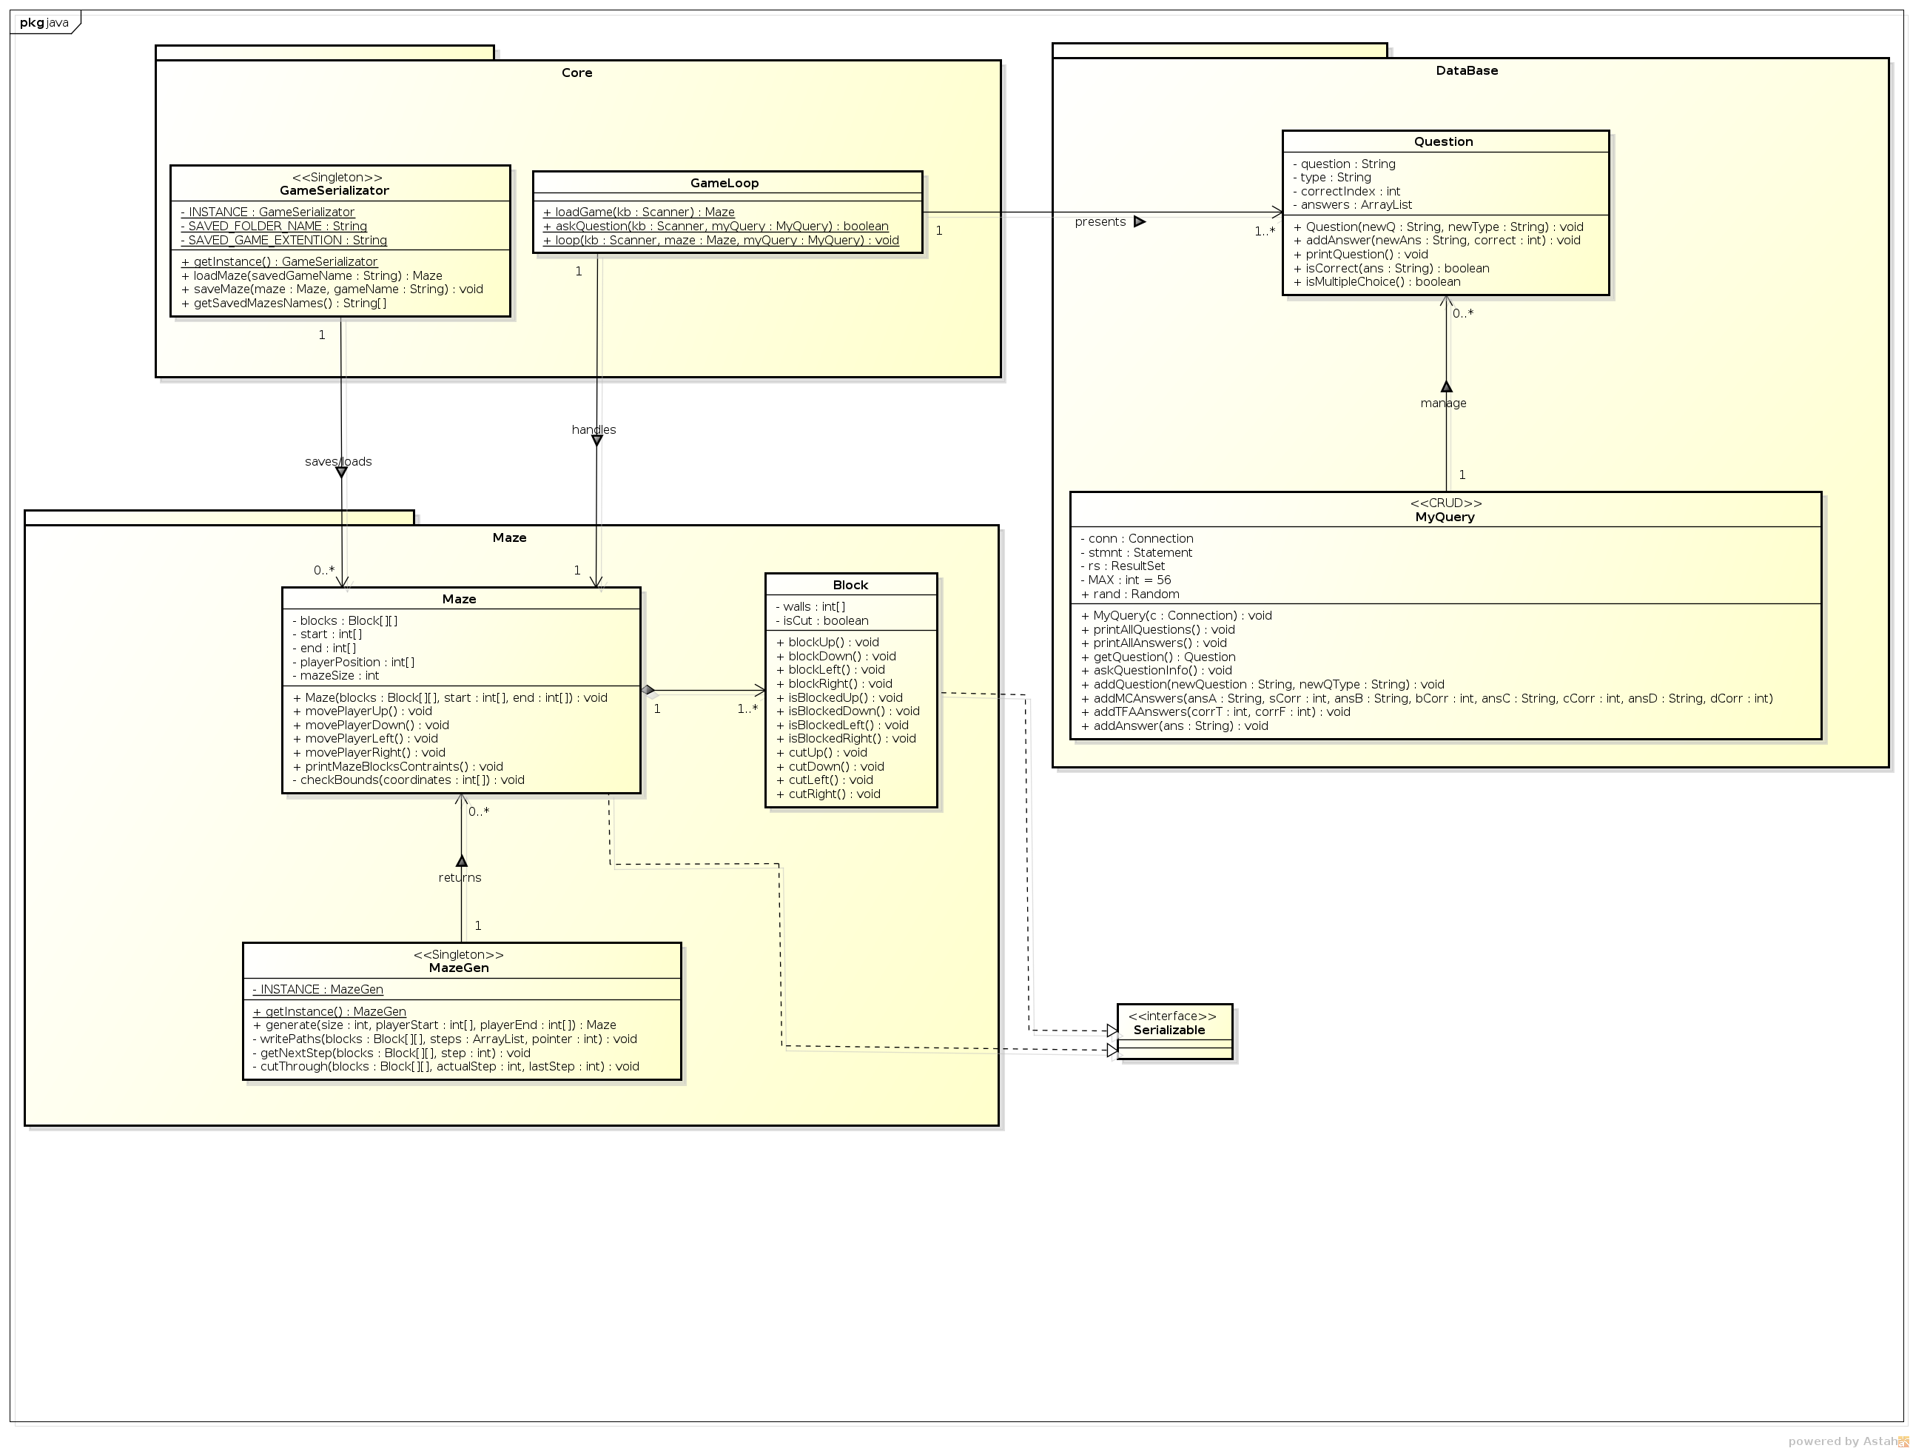

Class Diagram

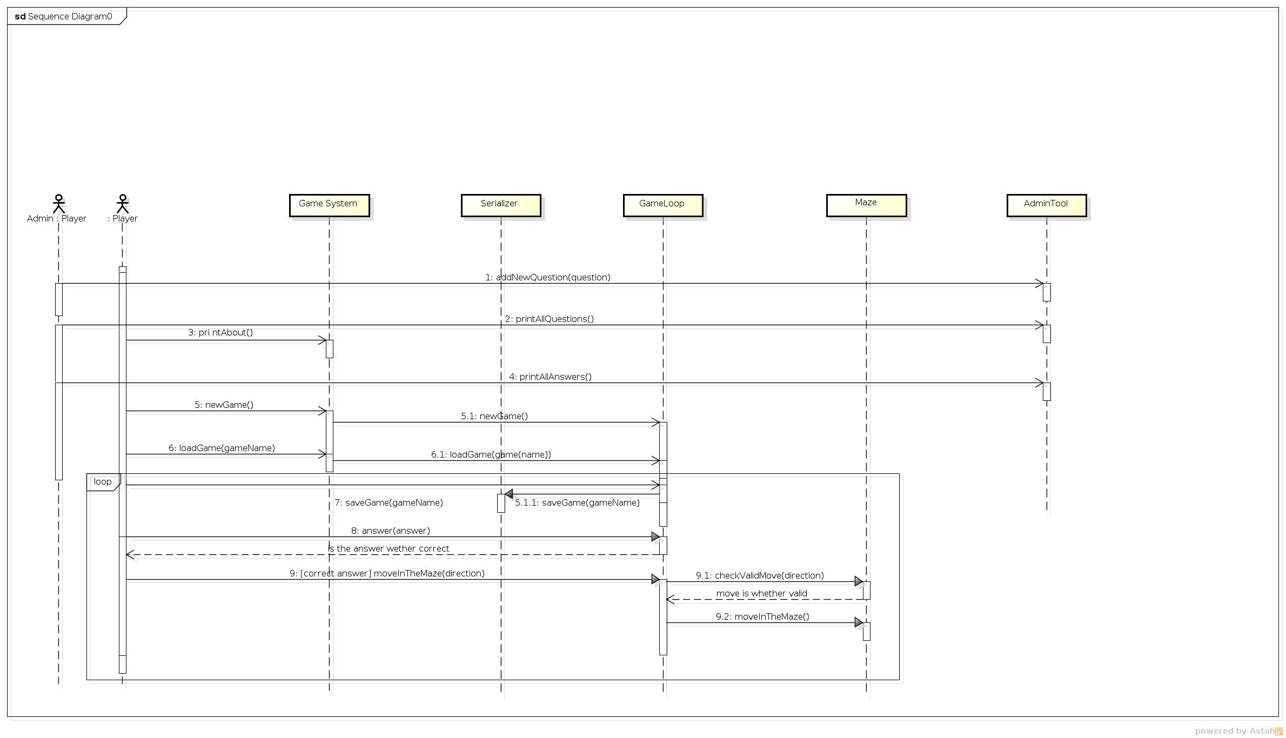

Sequence Diagram

Conceptual Model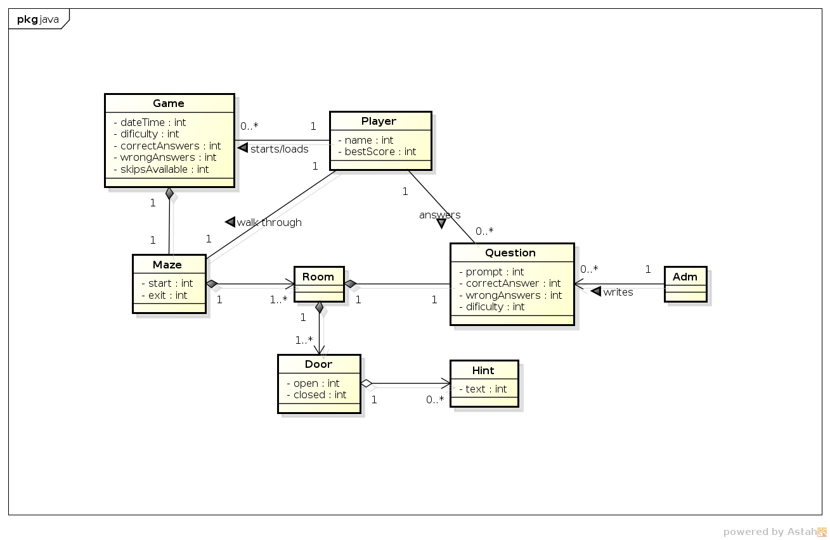

Use Case Diagram